ABSTRACT

The revelations about massive surveillance have created significant interest in algorithm substitution attack (ASA),where an honest implementation of a cryptographic primitiveis replaced by a subverted one which can help “big brother” to break cryptographic security while generating output indistinguishable from the honest output. The current known ASAs on public-key cryptography are either dedicated for a type of concrete constructions with specific internal, or restrictive when applying to the real-word cryptographic standards (Ateniese etal., ACM CCS’15; Russell et al., ACM CCS’17; Chen et al., ASIACRYPT’20). In this paper, we first present a practical undetectable substitution for a general randomized algorithm with certain structure such that the randomness can be revealed to the big brother. Then, instantiating this randomized algorithm,we present a series of ASAs on core primitives in public-key cryptography including public-key encryption, key encapsulation mechanism, key exchange, and digital signature. In particular, our ASAs are universal in the sense that they do not rely on the internal description of the underlying cryptographic algorithm.Moreover, our ASAs are also practical since they can affect not only the widely deployed cryptographic standards, but also the ongoing NIST post-quantum standards.

TABLE OF CONTENTS
SL.NO. | CHAPTERS | PAGE NO.
1. | Introduction | 1-4
2. | Literature Survey | 5-8
3. | Methodologies  3.1 key Genration  3.2 Encapsulation  3.3 Encryption  3.4 Signing  3.5 Impact  3.6 ASA Framework | 9-15
4. | Results  4.1 Practical ASA-I On Public-Key Cryptography 4.2 Runtime Experiments  4.3 Limitations | 16-22
5. | Conclusions and Future Enhancements | 23
 | References

LIST OF FIGURES

SL.NO. | FIGURE NO. | TITLE OF FIGURE | PAGE NO.
1. | 1.1 | Symmetric encryption | 2
2 | 3.1 | Overview | 9
3 | 3.1.1 | ASA On Key Generation Algorithms | 10
4 | 3.2 | Public Key Cryptographic Standards that are Susceptible to ASA | 11
5 | 3.6.1 | Undectability for A | 14
6 | 3.6.2 | Instantiation of symbols | 15
7 | 4.1.1 | Subversion Ae− I for randomized algorithm. | 16
8 | 4.1.2 | ASA on PKCA | 18
9 | 4.2.4.1 | Average runtime comparision | 21
10 | 4.2.4.2 | Statistical results of runtime | 22

CHAPTER 1
INTRODUCTION

REMARKABLE functionalities and security guarantees are believed to be achieved with modern cryptography. In general, the cryptosystems are analyzed in a model, where the implementations of cryptographic algorithms are assumed to follow the “official” specifications. However, such an assumption might not hold in practice due to the fact the implementations might be maliciously subverted by manufacturers (e.g., Crypto AG) or supply-chain intermediaries so that some intelligence agencies (e.g., NSA) can easily break security and successfully conduct population-wide surveillance.
In a hardware-based cryptographic product, cryptographic algorithm is implemented using hardware security modules (HSM) to shield algorithmic internals from inspection. As declared by IBM 4769 Crypto Card, from the time of manufacture, the hardware is self-protecting such that if attacks are detected, HSM destroys critical internal states, and is rendered permanently inoperable. Therefore, when using hardware-based cryptographic products, the users are limited to input/output access, and have to trust that the cryptographic algorithm implementations by developers are truthful and do not contain any backdoor. Thus, it is vital to investigate what kind of means could be employed to subvert cryptographic algorithms.
Subversion on cryptosystem was first specifically considered by Young and Yung in the 1990s in the kleptographic framework, where the attackers steal information securely (exclusively), efficiently and subliminally (unnoticeably). Recently, this research area has been revitalized by Bellare et al. due to mass surveillance. In particular, the kleptographic attacks are formally treated as algorithm substitution attack (ASA), where the attacker (also called “big brother”) can replace the real cryptographic algorithm by a malicious one. A successful ASA should satisfy
- Undetectability: The subverted algorithm should be (computationally or statistically) indistinguishable from the legitimate one by black-box tests (i.e., the detector has only input-output access to the subverted algorithm).

- Recoverability: The secret information (secret key or plaintext) of the users using the subverted algorithm can be efficiently recovered.
An ASA is called universal if its implementation does not rely on the internal description of the underlying cryptographic algorithm, which is more desirable (from the point of view of big brother) due to the wider applications.
Analyzing whether the standardized cryptographic algorithms are vulnerable to ASAs is of particular importance since they are widely deployed, and subverting them is more devastating. In 2016, NIST initiated a PQC (Post-Quantum Cryptography) process to solicit, evaluate, and standardize new cryptographic algorithms including public-key encryption (PKE), key encapsulation mechanism (KEM), and digital signature (DS). The candidates to be standardized and round Submissions were announced on July 5, 2022. As the next-generation public-key standards, these candidates might serve as replacements of the currently deployed public-key cryptosystems. Thus, we also need to evaluate whether these NIST-PQC candidates are vulnerable to the potential malicious subversion attacks.

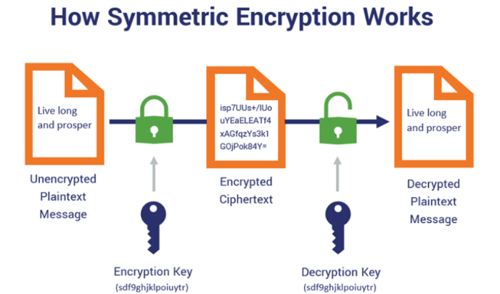
Figure 1.1: Symmetric encryption
Since, there has been an increased interest in ASA against various cryptographic primitives. For the symmetric cryptography, Bellare et al. proposed universal ASAs that can be applied to all the sufficiently randomized symmetric encryption schemes including the standardized ones. Unfortunately, different from the symmetric encryption case the currently known ASAs on public-key cryptography are either dedicated for

several specific algorithms, or restrictive when applied to the real-world cryptographic standards.
For the key generation algorithm (the most fundamental component in PKE, KEM, key exchange (KE), and digital signature.), Young and Yung demonstrated several specific ASAs on concrete algorithms, e.g., RSA, Diffie-Hellman (temporary) key generation, etc.. Yang et al.proposed ASAs on LWE-like key generation. These ASAs are quite efficient, but not universal since they rely on the internal descriptions of algorithms. In particular, these ASAs cannot be applied to the key generation of some post-quantum cryptosystems, e.g., the NIST-PQC candidates including CRYSTALS-KYBER, CRYSTALS-DILITHIUM, FALCON, etc.. Up to now, there are no universal ASAs that can be applied to a general key generation. This leads to a natural question:
Q1: Is it possible to develop a universal ASA that can work for a general key generation in public-key setting?
For the encapsulation algorithm in a KEM, Chen et al. identifies two non-black-box properties, universal decryptablity and key-pseudo-randomness, which would yield practical ASAs that enable recovering the session key (except the initial session key) from only two successive ciphertexts. In particular, these non-black-box properties can be satisfied by a range of KEMs. Unfortunately, they are not satisfied by the current standardized KEMs deployed in the real-world cryptosystems, e.g., KEMs in ISO/IEC 18033-2 . In addition, these properties are also not met by any NIST-PQC KEM candidate. By now, there are no practical ASAs that can be applied to any standardized encapsulation algorithm.
Q2: Is there a practical ASA on encapsulation algorithm that can be applied to the current standardized KEMs and NIST-PQC KEM candidates?
For the encryption algorithm in a PKE scheme, Russell et al. showed a universal ASA (their main contribution was to defend such attacks) that can recover one bit of plaintext per ciphertext. As discussed by , the ASA in is inefficient for plaintext recovery due to the fact that the message m usually has quite large length and is rarely encrypted many

times, i.e., plaintexts are usually fresh across various encryption sessions in reality. When employing PKE in practice, the most prevalent way is hybrid cipher (also called KEM/DEM paradigm) standardized by ISO/IEC 18033-2, where a KEM is used to encapsulate a session key that is subsequently used to encrypt the plaintext by a data encapsulation mechanism (DEM). Chen et al. showed that the typical hybrid cipher is susceptible to ASAs if the KEM used satisfies the aforementioned non-black-box properties, which are not satisfied by ISO/IEC 18033-2. Xiao et al. and Yang et al. proposed several ASAs that can recover the messages on (Ring-)LWE encryption schemes with specific parameters. However, it is unclear whether their ASAs can be applied to general LWE-like encryptions (e.g., NISTPQC CRYSTALS-KYBER-PKE)
Q3: Is there a practical ASA on standardized hybrid cipher and ongoing NIST-PQC encryption algorithms such that the attacker can recover the whole messages?
For the signing algorithm in a DS scheme, Ateniese et al. developed a universal ASA that works for any sufficiently randomized signing. However, such an ASA requires at least O(λ) signatures to recover secret key, where λ is the security parameter. In particular, for ECDSA with 256-bit secret key sk, as evaluated by , their ASA requires 2048 signatures to recover sk. However, in some real-world settings, e.g., Bitcoins , most users do not use a fixed ECDSA secret key to produce so many signatures. In order to reduce the number of the required signatures, Liu et al.developed an ASA that can recover the secret key using just 2 successive signatures. Unfortunately, their work needs the DS scheme to be splittable (the signature can be divided into two parts, randomness-binded component independent of the message, and message-binded component), and randomness exchangeable, which are not satisfied by the real-world standards, e.g., DSA/ECDSA, NIST-PQC CRYSTALS-Dilithium etc. (see Supplemental Material IX-A).

CHAPTER 2
LITERATURE SURVEY

1. Homomorphic Encryption-Based Secure Data Sharing and Processing in Mobile Cloud Computing" by H. Zhang et al.
Contributions:
Introduction of Homomorphic Encryption: The paper introduces the concept of homomorphic encryption and its application in the context of secure data sharing and processing in mobile cloud computing. By leveraging homomorphic encryption, the proposed approach allows computations to be performed directly on encrypted data, thus preserving privacy.
Drawbacks:
Computational Overhead: Homomorphic encryption typically incurs significant computational overhead compared to plaintext operations. While the paper discusses the feasibility of performing computations on encrypted data, it may not fully address the performance implications, especially in resource-constrained mobile devices.
Scalability: The scalability of the proposed approach may be limited, particularly when dealing with large volumes of data or complex computations. Homomorphic encryption schemes often struggle with scalability due to the computational complexity involved, which could impact the practicality of the solution for real-world applications.
Key Management: The paper may not thoroughly discuss the challenges associated with key management in homomorphic encryption-based systems. Managing encryption keys securely, especially in distributed environments like mobile cloud computing, is crucial for ensuring the overall security of the system.

2. Attribute-Based Encryption for Secure Data Sharing in Mobile Cloud Computing" by J. Wang et al.
Contributions:
Secure Enclaves Implementation: The paper contributes to the field by implementing secure enclaves for privacy-preserving data encryption in mobile cloud computing environments. Secure enclaves offer hardware-based security mechanisms to protect sensitive computations and data.
Drawbacks:
Hardware Dependency: Secure enclaves rely on hardware support, such as Intel SGX or ARM TrustZone. Therefore, the availability and compatibility of secure enclave technology may be limited to certain hardware platforms, potentially restricting the applicability of the proposed approach to specific devices or environments.
Performance Overhead: While secure enclaves offer enhanced security, they may introduce performance overhead due to the additional computational and memory requirements associated with enclave operations. The paper should provide a thorough evaluation of the performance impact of using secure enclaves for data encryption in mobile cloud computing.

3. Privacy-Preserving Data Encryption for Big Data in Mobile Cloud Computing using Proxy Re-Encryption and Secure Multi-Party Computation" Authors: X. Chen, Y. Liu, Z. Zhang
Contributions:
Novel Approach: The paper introduces a novel privacy-preserving data encryption strategy for big data in mobile cloud computing by combining Proxy Re-Encryption (PRE) and Secure Multi-Party Computation (SMPC) techniques. This approach offers a unique solution to address privacy concerns in mobile cloud environments.
Drawbacks:
Complexity: Combining Proxy Re-Encryption and Secure Multi-Party Computation may introduce additional complexity to the encryption process, potentially increasing computational overhead and resource requirements. This could limit the scalability of the approach, especially for large-scale big data applications.
Implementation Challenges: Implementing and deploying Proxy Re-Encryption and Secure Multi-Party Computation techniques in mobile cloud computing environments may pose challenges in terms of compatibility, interoperability, and resource constraints. Practical deployment of the proposed approach may require careful consideration of these factors.

4. Secure and Efficient Data Transmission in Mobile Cloud Computing Using Proxy Re-Encryption"

Contributions:

Introduction of Proxy Re-Encryption (PRE): The paper introduces proxy re-encryption as a cryptographic primitive that allows a proxy entity to transform ciphertext encrypted under one key into ciphertext encrypted under another key, without knowledge of the underlying plaintext. This enables secure data transmission and sharing in mobile cloud computing environments.
Drawbacks:
Key Management Complexity: Proxy re-encryption schemes typically require the management of cryptographic keys for encryption, decryption, and re-encryption, which can introduce complexity in key management, especially in distributed environments like mobile cloud computing. The paper may not thoroughly address the challenges of key management in PRE-based systems.
Security Assumptions: The paper may make certain security assumptions about the trustworthiness of the proxy entity responsible for re-encryption operations. It may not thoroughly discuss potential security risks associated with the proxy entity, such as malicious behavior or compromise.
5. Privacy-Preserving Data Encryption using Secure Enclaves in Mobile Cloud Computing" by Z. Wang et al.
Contributions:
Secure Enclaves Implementation: The paper contributes to the field by implementing secure enclaves for privacy-preserving data encryption in mobile cloud computing environments. Secure enclaves offer hardware-based security mechanisms to protect sensitive computations and data.
Drawbacks:
Hardware Dependency: Secure enclaves rely on hardware support, such as Intel SGX or ARM TrustZone. Therefore, the availability and compatibility of secure enclave technology may be limited to certain hardware platforms, potentially restricting the applicability of the proposed approach to specific devices or environments.
Performance Overhead: While secure enclaves offer enhanced security, they may introduce performance overhead due to the additional computational and memory requirements associated with enclave operations. The paper should provide a thorough evaluation of the performance impact of using secure enclaves for data encryption in mobile cloud computing.

6. Privacy-Preserving Data Encryption Techniques for Big Data in Mobile Cloud Computing" by X. Liu et al.
Contributions:
Comprehensive Overview: The paper provides a comprehensive overview of various privacy-preserving data encryption techniques suitable for big data processing in mobile cloud computing. By covering a wide range of encryption methods, including homomorphic encryption, attribute-based encryption, proxy re-encryption, and secure multi-party computation, it offers a valuable resource for researchers and practitioners.
Drawbacks:
Limited Depth: While the paper offers a broad overview of privacy-preserving data encryption techniques, it may lack depth in the analysis of specific techniques. Readers may find it challenging to gain a detailed understanding of individual encryption schemes due to the breadth of coverage.
Future Directions: The paper could provide more comprehensive insights into future research directions or areas for improvement in privacy-preserving data encryption techniques for big data in mobile cloud computing. It would benefit from discussing emerging trends, challenges, and opportunities for further advancements in the field.

CHAPTER 3
METHODOLOGIES
The proposed system includes five major sections:
- Key Generation
- Encapsulation
- Encryption
- Signing
- Impact
- ASA Framework

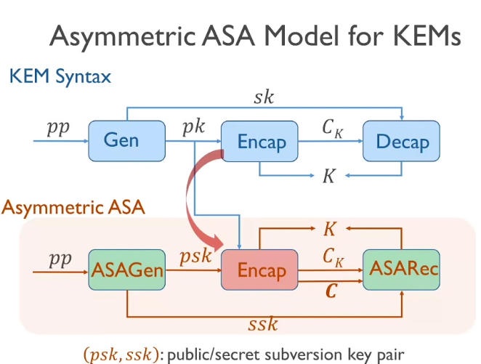
Figure 3.1 Overview

3.1 KEY GENERATION
We present a practical ASA that works for any key generation algorithm with one-way security, which is a basic requirement for key generation, and means that given a randomly generated public key, it’s hard to find a matching secret key. As shown by Figure 3.1, our ASA can affect all the currently known key generation algorithms in public-key cryptography, including the widely deployed standards (e.g., RSA cryptosystem, elliptic curve cryptosystem), and the ongoing NIST-PQC candidates [ including lattice based cryptosystem, code-based cryptosystem, multivariate polynomial cryptosystem, etc..

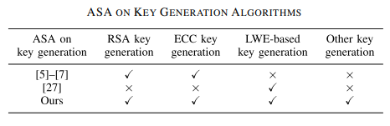
Figure 3.1.1. ASA On Key Generation Algorithms

3.2 ENCAPSULATION

We present a practical ASA that works for any encapsulation algorithm with basic one-way security, which means that given a randomly generated encapsulation, it’s hard to find a matching session key. As shown by Figure 3.2, our ASA can be applied to not only all the widely-deployed standardized KEMs in ISO/IEC 18033-2, but also all the NIST-PQC candidates .

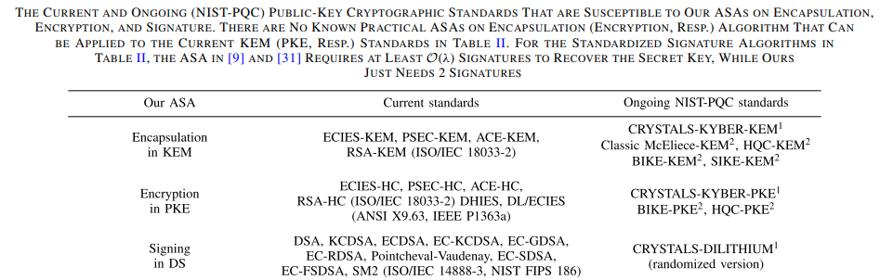
Figure 3.2. Public Key Cryptographic Standards that are Susceptible to ASA

3.3 ENCRYPTION
We present a practical ASA that works for any encryption algorithm in a well-spread PKE with decryptability-with-randomness (DWR) property. In particular, all the messages encrypted by the subversion can be efficiently recovered. Roughly speaking, well-spreadness says that the ciphertexts generated by the encryption algorithm have sufficiently large min-entropy. The DWR property indicates that given a ciphertext and the corresponding randomness used in encryption, one can efficiently recover the encrypted message. The well-spreadness and the DWR property are not only satisfied by the well-known ElGamal , its variants DHIES, DL/ECIES (standardized by IEEE P1363a and ANSI X9.63) and generic hybrid cipher standardized by ISO/IEC 18033-2, but also met by NIST-PQC PKE candidates including LWE-like and code-based encryptions, see Figure 3.2. Thus, our ASA on encryption can be applied to all these PKEs.

3.4 SIGNING
We present a practical ASA that works for any signing algorithm in a well-spread DS scheme with randomness-leakage-vulnerable (RLV) property. Wellspreadness means that signatures generated by the signing algorithm have sufficiently large min-entropy. The RLV property of a signing algorithm Sign says that given message m, randomness r, and a signature σ such that σ = Sign(sk, m;r), one can efficiently recover secret key sk. For the well-known Fiat-Shamir-type signatures, the well-spreadness is implied by the standard EUF-CMA (existential unforgeable under chosen message attacks) security. In

addition, the RLV is also an intrinsic property of a Fiat-Shamir-type signature.Thus, our ASA on signature can be applied to all the Fiat-Shamir-type signatures, including the widely-deployed standardized signature schemes in ISO/IEC 14888-3 and NIST FIPS 186 and the NIST-PQC candidates, see Table II. More importantly, our ASA subversion is undetectable and the secret key used in the subversion can be efficiently recovered with just two successive signatures, while the prior ASA in and requires at least O(λ) signatures.

3.5 IMPACT
Our results have strong implications in practice, since they can be applied to the widely-deployed cryptographic standards that covered all the three core cryptographic functionalities in public-key cryptography, i.e., PKE, KEM/KE and DS. These standards are the basis of the real-world cryptographic protocols such as TLS/SSL, SSH, IKE, etc.. Thus, our results indicate that all these widely-deployed cryptographic protocols are all susceptible to ASA, which is far more effective and dangerous than previously believed. In particular, it is hard to detect whether such an ASA is injected by manufacturers into the real-word (especially hardware-based) cryptosystems. In addition, our results can also be applied to the ongoing NIST-PQC candidates, which might become an evidence to drive NIST to take the potential ASA into consideration when standardizing PQC algorithms. For example, the schemes that are immune to our ASAs should have priority over other schemes. Our subversions of the current and next-generation cryptographic standards have a similar practical exploitability to the well-known NIST Dual EC DRBG. Simple modifications to circumvent our ASAs seems hard to find, please refer to Sec. VIII for the discussions on the defenses. Thus, our results will further increase interest in design and application of practical defenses.

3.6 ASA FRAMEWORK
The ASA adversary wishes to supply a subverted cryptographic implementation in order to break security while keeping the subversion undetectable “under the radar”. Gen (key

generation algorithm in various public-key schemes), Encaps (encapsulation algorithm in KEM), Enc (encryption algorithm in PKE) and Sign (signing algorithm in DS) are four fundamental randomized algorithms in public key cryptography. Before giving the concrete ASA definitions for Gen, Encaps, Enc and Sign, we first present our unified subversion framework for a general randomized algorithm.
Let A be a randomized algorithm that on input x and randomness r outputs y = (ypub, ypri), where ypub (ypri , resp.) is public (private, resp.), and r is picked uniformly from R at random. That is, (ypub, ypri) = A(x;r).
Instantiation: The algorithm A can be instantiated by Gen, Encaps, Enc and Sign.
When A = Gen, x = 1 λ , ypub = pk and ypri = sk;
When A = Encaps, x = pk, ypub = c and ypri = K;
When A = Enc, x = (pk, m), ypub = c and ypri = ⊥;
When A = Sign, x = (sk, m), ypub = σ and ypri = ⊥.
The subverted algorithm Aemaintains the input-output interfaces as A and controls the generation of the randomness er. In particular, a backdoor key bdk is embedded into Ae by the ASA attacker. In addition, Ae can be stateful, even in case the original algorithm is not, and we denote the corresponding state by τ ∈ {0, 1} ∗ , which is only used internally by Ae and never outputted to the outside.

3.6.1 ASA ON A RANDOMIZED ALGORITHM
The undetectability of Ae can be seen as the computational indistinguishability between the honest A and the subversion Ae via black-box access. In this paper, we consider the ASA attacker whose goal is to recover the randomness of Ae by monitoring the public channel.
Definition-1 (Undetectability for A): Let A be the subver- e sion of a randomized algorithm A. Let z be some auxiliary parameter associated with A (the instantiation of z is given by Figure 3.6.2). Let τ be internal state of A. Given e a distinguisher D (also

called detector) against the detection game in Figure 3.6.1, define the advantage AdvA DET(D) := |2 Pr[DET(D) = 1] − 1| = | Pr[1 ← DA,Reset(z)] − Pr[1 ← DAe,Reset(z)]|.

We say A is undetectable if e AdvA DET(D) is negligible for any PPT distinguisher D. Definition-2 (Recoverability for A): Let A be the subveresion of A. Given X = {xi : i ∈ [q]}, consider a recovery game, where the challenger C (i.e., the user) sequentially runs Ae(xi) → (y i pub, y i pri) for i from 1 to q, sends (y 1 pub, . . . , y q pub) to an ASA attacker A, and finally A returns (r ′ 1 , . . . ,r ′ q ) as a guessing of (r1, . . . ,rq ), where ri is the randomness used in A’s i-th run. e A’s advantage of recovering the randomness in a subset T ⊆ [q] is defined as AdvAe,T Rec (A) := Pr[r ′ i = ri : i ∈ T ]. We say A wins the recovery game with rate (t, q) (0 ≤ t ≤ q), if there exists a set T such that |T | = t and AdvAe,T Rec (A) is non-negligible for any X.

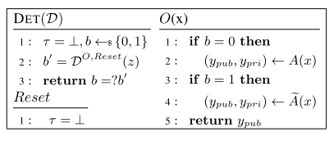
Figure 3.6.1.Undectability for A

3.6.2 ASA ON GEN/ENCAPS/ENC/SIGN
Instantiating the randomized algorithm A with concrete cryptographic algorithms Gen/Encaps/Enc/ Sign, we can obtain the following undetectability definition.
Definition-3 (Undetectability for Gen/Encaps/Enc/ Sign): Let A be a subverted algorithm of a public-key cryptographic e algorithm A (A ∈ {Gen, Encaps, Enc, Sign}) provided by an ASA attacker A. Given a distinguisher D and a security parameter λ, define the advantage AdvA DET(D) := | Pr[1 ← DA,Reset(z)]−Pr[1 ← DAe,Reset(z)]|, where the definition of Reset is shown in Fig. 2, and the instantiation of z is shown in Table III. We say A is undetectable if the advantage e AdvA DET(D) is negligible for any PPT distinguisher D.

Remark: Our undetectability definition is similar to the secret undetectability in and , except that the distinguisher is additionally allowed to reset the internal state of the algorithmic implementation. The (weaker) public undetectability (the distinguisher D is

only provided pk) in and is implied by the secret undetectability, and thus not discussed in this paper. For simplicity, we only consider a single-user setting. One could extend our results to the multi-user setting.
Definition-4 (Recoverability for Gen/Encaps/Enc): Let Ae be a subversion of A provided by an ASA attacker A. Given auxiliary parameter z = (z1,z2), and xi = (x 1 i , x 2 i ), consider a recoverability game, where the challenger C (i.e., the user) sequentially runs Ae(xi) → y i (yi = (y i pub, y i pri)) for i from 1 to q, sends (y 1 pub, . . . , y q pub) to A, and finally A returns (s ′ 1 , . . . ,s ′ q ) as a guessing of secrets (s1, . . . ,sq ). The instantiations of A, z, xi , yi , and si for Gen, Encaps, and Enc are given by Table III. A’s advantage of recovering all the secrets si (i ∈ T ) is defined as AdvAe,T Rec (A) := Pr[s ′ i = si : i ∈ T ]. We say an ASA attacker A wins the recoverability game with rate (t, q) (0 ≤ t ≤ q), if there exists a set T such that |T | = t and AdvAe,T Rec (A) is non-negligible for all z and xi .

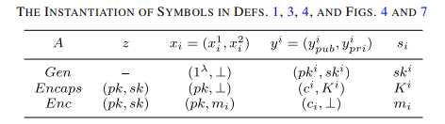
Figure 3.6.2.Instantiation of symbols
Definition-5 (Recoverability for Sign): Denote Sign as the ] subversion of Sign. Given security parameter λ, (pk,sk) ← Gen(1 λ ) and M = {mi : i ∈ [q]}, consider a recover ability game, where the challenger C(1 λ , pk,sk) (i.e., the user), sequentially runs Sign ](sk, mi) for i from 1 to q, gets (σ1, . . . , σq ), sends ((m1, σ1), . . . , (mq , σq )) to ASA attacker A, and finally A returns sk′ as a guessing of sk. A’s advantage can be defined as Adv]Sign Rec (A) := Pr[sk′ = sk]. We say A wins above recoverability game, if Adv]Sign Rec (A) is non-negligible for any M and (pk,sk) ← Gen(1 λ ).

CHAPTER 4
RESULTS

4.1 PRACTICAL ASA-I ON PUBLIC-KEY CRYPTOGRAPHY
In this section, we present a practical ASA-I on four fundamental algorithms including Gen, Encaps, Enc and Sign. For Gen/Encaps/Enc, our ASA-I attacker can recover q − 1 secrets from q outputs for any q ≥ 2. That is, the recovery rate is (q−1, q). For Sign, our ASA-I can recover the secret key from any two successive outputs. In the following, we first give a universal subversion Ae − I on a general randomized algorithm A. Then, we show how to instantiate Ae− I to derive our ASA-I on Gen, Encaps, Enc and Sign.

4.1.1 Subversion Ae− I on General Randomized Algorithm
The idea of Ae−I is to deterministically generate randomness using previous public information and a backdoor such that the future randomness can be exclusively predicted by the attacker (the backdoor owner). Concretely, as shown by Fig. 3, the Ae−I will always use the last y i pub to generate the next randomness by a secure PRF f with a backdoor key bdk. In particular, a temporary τ is utilized to record y i pub. For the initial run of Ae, the randomness r1 is just uniformly picked from R as in the normal case. Now, we first show such a subversion is undetectable.
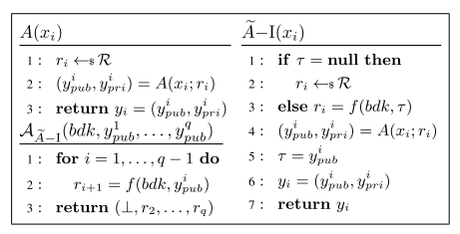
Figure 4.1.1. Subversion Ae− I for randomized algorithm.

Definition-6 (Partial-Injectivity): A randomized algorithm A is said to be partially-injective if δ A inj = maxx1,x2 | Pr[y 1 pub = y 2 pub : (y 1 pub, y 1 pri) = A(x1;r1), (y 2 pub, y 2 pri) = A(x2;r2), r1 ←$ R,r2 ←$ R]| is negligible.
Roughly speaking, the partial-injectivity property of A says that it is infeasible (for detector) to find a collision among A’s public outputs. It is to see that the undetectability of Ae−I can be reduced to the partial-injectivity and the PRF security. Thus, we have Theorem 1, whose proof is given by Supplemental Material IX-C.
Theorem-1 (Undetectability of Ae− I): If a randomized algorithm A is partially-injective and the f used in Ae − I (Fig. 3) is a secure PRF, then Ae − I is undetectable. In particular, for any distinguisher D between A and Ae − I that makes at most p queries, there exists a distinguisher D′ against the PRF security such that AdvA DET(D) ≤ p 2 δ A inj + AdvP RF (D′ ).
Remark: In fact, for A, the partial-injectivity can be further reduced to the min-entropy 5 of ypub (A’s public output). When instantiating A with Enc (Sign, resp.), such a min-entropy can be directly adapted as the well-spreadness. But, for Gen and Encaps, in contrast to the min-entropy, the partial-injectivity can be reduced to the one-way security in a more straight-forward manner. Thus, in Theorem 1, we just reduce the undetectability of Ae− I to the partial-injectivity of A rather than the min-entropy of ypub.
Theorem-2 (Recoverability of Ae− I): For the subversion Ae− I of a randomized algorithm A (Fig. 3), there exists an extracting algorithm AAe−I with bdk such that AAe−I can win the recovery game with rate (q − 1, q) for any q ≥ 2, where q is the number of the (public) outputs observed by AAe−I and q − 1 is the number of randomness recovered by AAe−I .

4.1.2 ASA-I on Public-Key Cryptography
Next, we show how to instantiate Ae − I to mount ASAs on core cryptographic algorithms, Gen/Encaps/Enc/Sign. Since Gen g, Encaps ^ , Enc g, and Sign ] are the instantiations of Ae − I, we just need to argue the partial-injectivity when proving undetectability according to Theorem-1.

Definition-7 (One-Wayness of Gen): Let pk be a target public-key generated by running r ←$ R, (pk,sk) = Gen(1 λ ;r). Spk = {sk′ : (pk,sk′ ) = Gen(1 λ ;r),r ∈ R} is the set of secret keys that match with pk. The advantage of an adversary B outputting a secret key in Spk is defined as AdvGen OW (B) = Pr[sk ∈ Spk : sk ← B(pk)]. We say Gen is one-way secure if for any PPT B, AdvGen OW (B) is negligible.
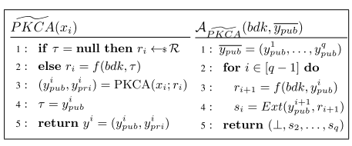
Figure 4.1.2. ASA on PKCA
Lemma-1: If a key generation (a KEM scheme, resp.) is one-way secure, then Gen (Encaps, resp.) is partially injective (Def. 6).
Proof: Let B(pk) (B(pk, c), resp.) be an adversary that runs as follows, r ′ ←$ R, (pk′ ,sk′ ) = Gen(1 λ ;r ′ ) ((c ′ , K ′ ) = Encaps(pk;r ′ ), resp.), returns sk′ (K ′ , resp.) if pk = pk′ (c = c ′ , resp.), and ⊥ otherwise. Note that the running time of B is about of Gen (Encaps, resp.). Thus, according to the definition of partial-injectivity, we have δ A inj = AdvA OW(B) (A ∈ {Gen, K E M}), which is negligible.

Lemma-2: If a PKE (DS, resp.) scheme is well-spread, then Enc (Sign, resp.) is partially-injective (Def. 6).
Proof: Given pk, m1, m2, r1, we define δm1,m2,r1 6 = Pr[c1 = c2 : c1 = Enc(pk, m1;r1),r2 ←$ R, c2 = Enc(pk, m2;r2)]. Then, according to Def. 6, we have δ Enc inj = maxm1,m2 |R| −1 P r1∈R δm1,m2,r1 . Since PKE is γ -spread, we can derive δm1,m1,r1 ≤ 2 −γ for any m1, m2 and r1. Hence, δ Enc inj ≤ 2 −γ . Using the same method, we can also derive δ Sign inj ≤ 2 −γ .
Combing Lemmas 1, 2 and Theorem 1, we directly obtain the following result.
Theorem 3 (Undetectability of ASA-I on Gen/Enc/ Encaps/Sign): If Gen (a KEM scheme, resp.) is one-way secure and the f is a secure PRF, Gen ( g Encaps, ^ resp.)

is undetectable (Def. 3). If a PKE (DS, resp.) scheme is well-spread and the PRF is a secure PRF, Enc ( g Sign, resp.) is undetectable (Def. ] 3).

Definition-8 (Decryptability-With-Randomness (DWR)): We say a PKE scheme has a DWR property, if there exists a PPT algorithm Exm such that for any pk, m, r, and c = Enc(pk, m;r), we have Exm(pk, c,r) = m. For brevity, we usually omit the input pk, and just write Exm(c,r) = m. Roughly speaking, the DWR property says that if one gets the randomness used in the Enc, he can efficiently recover the message m.

Definition-9 (Randomness-Leakage-Vulnerable (RLV)): We say a DS scheme satisfies RLV property, if there exists a PPT algorithm Exk such that for any m, r, sk and σ = Sign(sk, m;r), we have Exk(pk, m,r, σ ) = sk. For brevity, we usually omit pk, and just write Exk(m,r, σ ) = sk. For the subversions, we can construct the corresponding extracting algorithm. For Gen (Encaps, resp.), once the ri is obtained, one can directly derive ski (K i , resp.) with probability 1 by running Gen (Encaps, resp.) using ri . For PKE with DWR (DS with RLV, resp.) property, if ri is obtained, one can also derive the message mi (the secret key sk, resp.) with probability 1. According to Theorem 2, we have the following result.

Theorem-4 (Recoverability of ASA-I on Gen/Enc/ Encaps/Sign): For the subversions of Gen, Encaps, and Enc (in a PKE with DWR property), the PPT extracting algorithms A can win the recovery game (Def. 4) with rate (q − 1, q) (q ≥ 2), where q is the number of the (public) outputs observed by A, q − 1 is the number of secrets recovered by A. Concretely, for any q ≥ 2, the ASA-I attacker A with the backdoor key bdk can recover q − 1 secrets (secret key for key generation, session key for encapsulation and message for encryption) from any q successive outputs. For the subversion of Sign (in a DS with RLV property), the PPT extracting algorithms A can win the recovery game (Def. 5). In particular, the ASA-I attacker A can derive the secret key from any two successive signatures.

4.2 RUNTIME EXPERIMENTS
Instantiating PKE, KEM and DS by ECIES, ECIES-KEM in ISO/IEC 18033-2, and ECDSA in ISO/IEC 14888-3 respectively, we do experiments for key generation, encapsulation, encryption, and signing following he honest specification, our subversions, and prior subversions on key generation (denoted by YY97) and on signing, (denoted by AMV15).

4.2.1 Key Generation
Given an elliptic curve group E of order p and a primitive element P in E (in our implementation we use the recommended parameters secp256k1), the key generation algorithm of ECIES outputs pk = (E, P, p, Q = a · P) and sk = (a, pk). In an honest implementation, a ←$ [p −1]. In YY97, a is generated by H(Y a1 ), where a1 is the secret key in the last invocation, and Y = x · P (only the “big brother” knows x). In our ASA, a is generated by f (bdk, Q1), where Q1 is the public key in the last invocation.

4.2.2 Encapsulation
Given pk = (E, P, p, Q = a · P), the encryption algorithm of ECIES-KEM outputs (K,C), where C = r · P, x is the x-coordinate of r · Q, and K = K DF(C, x) (K DF is the key derivation function). In an honest implementation, r ←$ [p − 1]. In our ASA, r is generated by f (bdk,C1), where C1 is the encapsulated ciphertext in the last invocation.

4.2.3 Encryption
The encryption algorithm of ECIES adopts hybrid encryption. That is, given pk = (E, P, p, Q = a · P) and plaintext m, the ciphertext (C,C ′ ) is produced by running ECIES-KEM to obtain (C, K) and running an authenticated encryption algorithm (in our implementation AES-GCM is used) with K and m to get C ′ . In an honest implementation, the random number r used in ECIES-KEM is uniformly generated from [p − 1]. In our ASA, r is generated by f (bdk,C1), where C1 is the ciphertext in the last invocation.

4.2.4 Signing
The signing algorithm of ECDSA on input sk = (a, E, P, p, Q = a · P) and message m outputs σ = (t,s), where T = k · P, t is the x-coordinate of T , s = k −1 (H(m)+ t · a) mod p. In an honest implementation, k is uniformly generated from [p − 1]. In AMV15, the signature σ is generated by rejection sampling such that f (bdk, σ ) = a[i] for some random i. In our ASA, k is generated by f (bdk, σ1), where σ1 is the signature produced in the last invocation.
All these algorithms are implemented in python on a PC with CPU 2.8GHz Intel Core i9. In particular, all these implementations follow package eciespy 0.3.1 at https://pypi.org/project/eciespy/ and package ecdsa 0.16.1 at https://pypi.org/project/ecdsa/ . For every algorithm, we respectively implement one million times, and count the runtimes. The (average) runtime comparison is shown by Figure 4.2.4.1. Detailed statistical results of the runtime is shown by Figure 4.2.4.2.

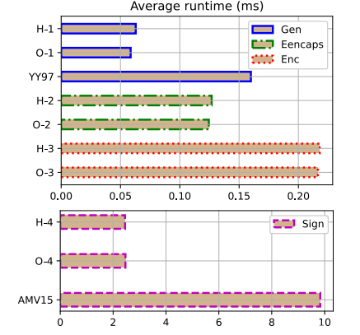
Figure 4.2.4.1.Average runtime comparision

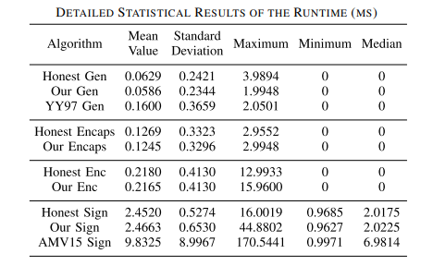
Figure 4.2.4.2.Statistical results of runtime

4.3 LIMITATIONS
- Several approaches have been proposed to defend against the ASAs, including
- Derandomization
- Split-program methodology
- cryptographic reverse firewall
- self-guarding mechanism

CHAPTER 5

CONCLUSIONS AND FUTURE ENHANCEMENT
- A universal subversion framework, and then instantiate this framework to a series of practical ASAs on essential public-key cryptographic algorithms including key generation, encapsulation, encryption, and signature, which are much more effective than existing ones.
- In particular, our ASAs can be applied to various widely deployed (and ongoing) cryptographic standards.
- Furthermore, implementing the unique-ciphertext public-key encryption which resists Subversion attacks.
- Implementing advanced security measures to fortify the project against evolving cyber threats. This may involve exploring and integrating the latest encryption standards, authentication protocols, and anomaly detection mechanisms to enhance the overall security posture of the system.
- Adapting the project for mobile platforms to cater to the growing number of users accessing applications through smartphones and tablets. This includes developing responsive designs, optimizing performance for mobile devices, and ensuring a consistent user experience across various screen sizes.

